Bahria University

Karachi Campus



**COURSE CODE: CEN-221**

**COURSE**: **Computer Architecture & Organization Lab**

**TERM: FALL 2020**

**CLASS: BSE- 3(B)**

**Project REPORT**

**Submitted By:**

|  |  |  |
| --- | --- | --- |
| S no. | Name | Enrollment |
| 01. | Adnan Sami | 02-131182-068 |
| 02. | Daniyal Hassan | 02-131192-060 |
| 03. | Muhammad Noman | 02-131192-043 |
| 04. | Muhammad Usman | 02-131192-041 |

**Submitted to:**

Engr. Rehan Baig

Remarks: Date: Signature: _______

MCQS Based Test System

**Project Report**

**Table of Contents**

**INTRODUCTION** 01

**BACKGROUND** 02

**DESCRIPTION.**………………………………………………………………………………03

**CONCEPTS USED** 04

**CODE** 05

**OUTPUT INTERFACES** 23

**CONCLUSION** 31

**INTRODUCTION**

The main goal of this project “**MCQs Based Test System”** is that it is designed to increase learning by requiring students to give a multiple-choice question test of certain subjects and to observe their response whether it is correct or not.This is a program that lets you set up a series of questions that respondents can also complete online. It can also be called as a game to test knowledge about a certain subject. This program also shows result of every student who has participated in the multiple-choice question test. In this way, the program maintains the record of students with the details of examination and students results.

**BACKGROUNG**

The **MCQs Test** consists of different questions specific to the context of the student. The reason behind development of this system is to help in managing and maintaining the students results as well as checking their progress. The program gives detailed result based on the performance of student. The details include subject details, student marks details, student name etc. Moreover, in an educational context, a MCQs quiz is usually a form of a student assessment, and one of the best way to assess a student’s intellectual ability.

**DESCRIPTION**

The Project **“MCQs Test based System”** is made using the **“MIPS”** with the help of **MARS**.

The project starts by asking the user OR student name who has participated in the **MCQs TEST**. Then, three (3) respective subjects appear on the screen. Now it depends upon the student’s choice that whom subject’s MCQs will he take first. Each subject has five (5) multiple choice questions and each of them has one (1) point.

**CONCEPTS USED**

The concepts of MIPS are:

* MIPS register names begin with a $.
* MIPS is a register-to-register, or load/store, architecture.
* MIPS uses three-address instructions for data manipulation.

**MIPs CODE**

|  |
| --- |
| .data |
|  | ask_op: .asciiz"Answer: " |
|  | game: .asciiz"\n\tQUIZ" |
|  | line: .asciiz"______________________________" |
|  | fullmarks: .asciiz"\tF.M=5\n" |
|  |  |
|  | score: .word 0 |
|  | box1: .asciiz"\n -------------\n" |
|  | s_card: .asciiz" | SCORECARD |\n" |
|  | box2: .asciiz" -------------\n**********************\n" |
|  | name: .asciiz"\nNAME:" |
|  | buffer: .space 30 |
|  | ask_name: .asciiz"\nEnter your name(30 letters maximum)=" |
|  | score_out: .asciiz"\nSCORE:" |
|  |  |
|  | head: .asciiz"\n******** General MCQ's Test ***********\n" |
|  | prompt: .asciiz "\n\t****Menu\n[0] Press Exit\t [1] Press Find Again\nSelect Option: " |
|  |  |
|  | .align 2 |
|  | varword: .word main,case0,case1,case2 |
|  | input: .asciiz "\n******** Select Subject *********\n[0] General Science\n[1] Computer Science\n[2] Islamiat \nSelect Option :" |
|  | msg_0: .asciiz "******* General Science MCQ'S *********" |
|  | ganswer: .byte 'c','c','d','b','a' |
|  | gques1: .asciiz"\n\n1. What is the capital of Pakistan ?\n" |
|  | gq1opa: .asciiz"a)Karachi\n" |
|  | gq1opb: .asciiz"b)Lahore\n" |
|  | gq1opc: .asciiz"c)Islamabad\n" |
|  | gq1opd: .asciiz"d)Balochistan\n" |
|  | gques2: .asciiz"\n\n2. What is the name of Current PM ?\n" |
|  | gq2opa: .asciiz"a)Nawaz Shareef\n" |
|  | gq2opb: .asciiz"b)Asif Ali Zardari\n" |
|  | gq2opc: .asciiz"c)Imran Khan\n" |
|  | gq2opd: .asciiz"d)Sheikh Rasheed\n" |
|  | gques3: .asciiz"\n\n3. Which is the outermost planet in the solar system?\n" |
|  | gq3opa: .asciiz"a)Mercury\n" |
|  | gq3opb: .asciiz"b)Pluto\n" |
|  | gq3opc: .asciiz"c)Uranus\n" |
|  | gq3opd: .asciiz"d)Neptune\n" |
|  | gques4: .asciiz"\n\n4. Astola Island is located in____________?\n" |
|  | gq4opa: .asciiz"a) Sindh\n" |
|  | gq4opb: .asciiz"b) Balochistan\n" |
|  | gq4opc: .asciiz"c) Punjab\n" |
|  | gq4opd: .asciiz"d) KPK\n" |
|  | gques5: .asciiz"\n\n5. What is the national food of Pakistan ?\n" |
|  | gq5opa: .asciiz"a)Mango\n" |
|  | gq5opb: .asciiz"b)Orange\n" |
|  | gq5opc: .asciiz"c)Banana\n" |
|  | gq5opd: .asciiz"d)Grapes\n" |
|  |  |
|  |  |
|  | msg_1: .asciiz "******* Computer Science MCQ'S *********" |
|  |  |
|  |  |
|  | canswer: .byte 'a','d','b','d','a' |
|  | cques1: .asciiz"\n\n1. The term ‘Computer’ is derived from__________?\n" |
|  | cq1opa: .asciiz"a) Latin\n" |
|  | cq1opb: .asciiz"b) German\n" |
|  | cq1opc: .asciiz"c) French\n" |
|  | cq1opd: .asciiz"d) Arabic\n" |
|  | cques2: .asciiz"\n\n2. The basic operations performed by a computer are__________?\n" |
|  | cq2opa: .asciiz"a) Arithmetic operation\n" |
|  | cq2opb: .asciiz"b) Logical operation\n" |
|  | cq2opc: .asciiz"c) Storage and relative\n" |
|  | cq2opd: .asciiz"d) All the above\n" |
|  | cques3: .asciiz"\n\n3. If a computer has more than one processor then it is known as__________?\n" |
|  | cq3opa: .asciiz"a) Uni-process\n" |
|  | cq3opb: .asciiz"b) Multi-processing\n" |
|  | cq3opc: .asciiz"c) Multi programming\n" |
|  | cq3opd: .asciiz"d) Multi threading\n" |
|  | cques4: .asciiz"\n\n4. WWW stands for___________?\n" |
|  | cq4opa: .asciiz"aA. World Whole Web\n" |
|  | cq4opb: .asciiz"b) Wide World Web\n" |
|  | cq4opc: .asciiz"c) Web World Wide\n" |
|  | cq4opd: .asciiz"d) World Wide Web\n" |
|  | cques5: .asciiz"\n\n5.What type of operating system MS-DOS is?\n" |
|  | cq5opa: .asciiz"a) Command Line Interface\n" |
|  | cq5opb: .asciiz"b) Graphical User Interface\n" |
|  | cq5opc: .asciiz"c) Multitasking\n" |
|  | cq5opd: .asciiz"d) Menu Driven Interface\n" |
|  |  |
|  | msg_2: .asciiz "******* Islamiat MCQ'S *********" |
|  |  |
|  | sanswer: .byte 'b','c','c','d','c' |
|  | sques1: .asciiz"\n\n1. Prophet Muhammad (PBUH) belonged to __________ family.\n" |
|  | sq1opa: .asciiz"a) Makki\n" |
|  | sq1opb: .asciiz"b) Hashmi\n" |
|  | sq1opc: .asciiz"c) Quraishi \n" |
|  | sq1opd: .asciiz"d) Madni\n" |
|  | sques2: .asciiz"\n\n2.In the beginning Prophet Muhammad (PBUH) worked as a shepherd for __________?\n" |
|  | sq2opa: .asciiz"a) Banu Ummayya\n" |
|  | sq2opb: .asciiz"b) Banu Asad\n" |
|  | sq2opc: .asciiz"c) Banu Saad\n" |
|  | sq2opd: .asciiz"d) Banu Makhzoom\n" |
|  | sques3: .asciiz"\n\n3. To what Prophet the Zabur was revealed by Allah?\n" |
|  | sq3opa: .asciiz"a) Prophet Moosa (A.S)\n" |
|  | sq3opb: .asciiz"b) Prophet Ibraheem (A.S)\n" |
|  | sq3opc: .asciiz"c) Prophet Dawood (A.S)\n" |
|  | sq3opd: .asciiz"d) Prophet Essa (A.S)\n" |
|  | sques4: .asciiz"\n\n4. To what Prophet the Injeel was revealed by Allah?\n" |
|  | sq4opa: .asciiz"a) Prophet Ibraheem (A.S\n" |
|  | sq4opb: .asciiz"b) Prophet Dawood (A.S)\n" |
|  | sq4opc: .asciiz"c) Prophet Moosa (A.S)\n" |
|  | sq4opd: .asciiz"d) Prophet Essa (A.S)\n" |
|  | sques5: .asciiz"\n\n5. What companion of Prophet (PBUH) was awarded with the title of “The sword of Allah”?\n" |
|  | sq5opa: .asciiz"a) Ali Al-Murtaza (R.A)\n" |
|  | sq5opb: .asciiz"b) Umar Farooque (R.A)\n" |
|  | sq5opc: .asciiz"c) Khalid bin Waleed (R.A)\n" |
|  | sq5opd: .asciiz"d) Abu Bakr Siddique (R.A)\n" |
|  |  |
|  |  |
|  |  |
|  |  |
|  | .text |
|  | main: |
|  |  |
|  | li $t6,1 # Select option |
|  |  |
|  | WhileLoop: |
|  |  |
|  | beq $t6, 0, exit |
|  |  |
|  | li $v0,4 |
|  | la $a0,head |
|  | syscall |
|  |  |
|  | la $a0, ask_name |
|  | li $v0, 4 |
|  | syscall |
|  |  |
|  | li $v0, 8 |
|  |  |
|  | la $a0, buffer |
|  | li $a1,20 |
|  |  |
|  | move $t4, $a0 |
|  | syscall |
|  |  |
|  |  |
|  | la $a0, game |
|  | li $v0, 4 |
|  | syscall |
|  |  |
|  | la $a0, fullmarks |
|  | li $v0, 4 |
|  | syscall |
|  |  |
|  | la $a0,line |
|  | li $v0, 4 |
|  | syscall |
|  |  |
|  | ## |
|  | li $v0,4 |
|  | la $a0,input #print input message |
|  | syscall |
|  |  |
|  | li $v0,5 #read integer |
|  | syscall |
|  |  |
|  | addi $v0,$v0,1 |
|  | li $s0,10 |
|  | bltz $v0,main #default for less than 0 |
|  | bgt $v0,$s0,main # if greater than 9 |
|  |  |
|  | la $a1,varword #load address of varword |
|  | sll $t0,$v0,2 #compute word offset |
|  | add $t1,$a1,$t0 #form a pointer into variable |
|  | lw $t2,0($t1) #load an address from varword |
|  | jr $t2 #jump register to specific case that work as switch |
|  |  |
|  | case0: |
|  | li $v0,4 |
|  | la $a0, msg_0 |
|  | syscall |
|  | # GS Mcq starts |
|  |  |
|  | la $a0, gques1 |
|  | li $v0, 4 |
|  | syscall |
|  | la $a0, gq1opa |
|  | li $v0, 4 |
|  | syscall |
|  | la $a0, gq1opb |
|  | li $v0, 4 |
|  | syscall |
|  | la $a0, gq1opc |
|  | li $v0, 4 |
|  | syscall |
|  | la $a0, gq1opd |
|  | li $v0, 4 |
|  | syscall |
|  |  |
|  | la $a0, ask_op |
|  | li $v0, 4 |
|  | syscall |
|  | li $v0, 12 |
|  | syscall |
|  |  |
|  | #addi $t6, $t6, -1 |
|  | #bnez $t6, EXIT |
|  | la $t0, ganswer |
|  | lb $t1, 0($t0) |
|  | bne $t1, $v0,gL1 |
|  | addi $t7,$t7,1 |
|  |  |
|  | gL1:move $v0, $0 |
|  | la $a0, gques2 |
|  | li $v0, 4 |
|  | syscall |
|  | la $a0, gq2opa |
|  | li $v0, 4 |
|  | syscall |
|  | la $a0, gq2opb |
|  | li $v0, 4 |
|  | syscall |
|  | la $a0, gq2opc |
|  | li $v0, 4 |
|  | syscall |
|  | la $a0, gq2opd |
|  | li $v0, 4 |
|  | syscall |
|  |  |
|  | la $a0, ask_op |
|  | li $v0, 4 |
|  | syscall |
|  | li $v0, 12 |
|  | syscall |
|  |  |
|  | #addi $t6, $t6, -1 |
|  | #bnez $t6, EXIT |
|  |  |
|  | lb $t1, 1($t0) |
|  | bne $t1, $v0,gL2 |
|  | addi $t7,$t7,1 |
|  |  |
|  | gL2:move $v0, $0 |
|  | la $a0, gques3 |
|  | li $v0, 4 |
|  | syscall |
|  | la $a0, gq3opa |
|  | li $v0, 4 |
|  | syscall |
|  | la $a0, gq3opb |
|  | li $v0, 4 |
|  | syscall |
|  | la $a0, gq3opc |
|  | li $v0, 4 |
|  | syscall |
|  | la $a0, gq3opd |
|  | li $v0, 4 |
|  | syscall |
|  |  |
|  | la $a0, ask_op |
|  | li $v0, 4 |
|  | syscall |
|  | li $v0, 12 |
|  | syscall |
|  |  |
|  |  |
|  | lb $t1, 2($t0) |
|  | bne $t1, $v0,gL3 |
|  | addi $t7,$t7,1 |
|  |  |
|  |  |
|  | gL3:move $v0, $0 |
|  | la $a0, gques4 |
|  | li $v0, 4 |
|  | syscall |
|  | la $a0, gq4opa |
|  | li $v0, 4 |
|  | syscall |
|  | la $a0, gq4opb |
|  | li $v0, 4 |
|  | syscall |
|  | la $a0, gq4opc |
|  | li $v0, 4 |
|  | syscall |
|  | la $a0, gq4opd |
|  | li $v0, 4 |
|  | syscall |
|  |  |
|  | la $a0, ask_op |
|  | li $v0, 4 |
|  | syscall |
|  | li $v0, 12 |
|  | syscall |
|  |  |
|  | lb $t1, 3($t0) |
|  | bne $t1, $v0,gL4 |
|  | addi $t7,$t7,1 |
|  |  |
|  | gL4:move $v0, $0 |
|  | la $a0, gques5 |
|  | li $v0, 4 |
|  | syscall |
|  | la $a0, gq5opa |
|  | li $v0, 4 |
|  | syscall |
|  | la $a0, gq5opb |
|  | li $v0, 4 |
|  | syscall |
|  | la $a0, gq5opc |
|  | li $v0, 4 |
|  | syscall |
|  | la $a0, gq5opd |
|  | li $v0, 4 |
|  | syscall |
|  |  |
|  | la $a0, ask_op |
|  | li $v0, 4 |
|  | syscall |
|  | li $v0, 12 |
|  | syscall |
|  |  |
|  | lb $t1, 4($t0) |
|  | bne $t1, $v0, gEXIT |
|  | addi $t7,$t7,1 |
|  |  |
|  |  |
|  | gEXIT: |
|  | add $t9,$t9,$t7 |
|  | sw $t9,score |
|  |  |
|  |  |
|  | la $a0, box1 |
|  | li $v0, 4 |
|  | syscall |
|  |  |
|  | la $a0, s_card |
|  | li $v0, 4 |
|  | syscall |
|  |  |
|  | la $a0, box2 |
|  | li $v0, 4 |
|  | syscall |
|  |  |
|  | la $a0, name |
|  | li $v0, 4 |
|  | syscall |
|  |  |
|  | la $a0, buffer |
|  | move $a0, $t4 |
|  | li $v0, 4 |
|  | syscall |
|  |  |
|  | la $a0, score_out |
|  | li $v0, 4 |
|  | syscall |
|  |  |
|  | move $a0, $t9 |
|  | li $v0, 1 |
|  | syscall |
|  |  |
|  | move $v0, $0 |
|  | # GS Mcq end |
|  | #b exit |
|  |  |
|  | li $v0,4 |
|  | la $a0,prompt |
|  | syscall |
|  | li $v0,5 |
|  | syscall |
|  | move $t6,$v0 |
|  |  |
|  | j WhileLoop |
|  |  |
|  | case1: |
|  |  |
|  | li $v0,4 |
|  | la $a0, msg_0 |
|  | syscall |
|  |  |
|  | la $a0, cques1 |
|  | li $v0, 4 |
|  | syscall |
|  | la $a0, cq1opa |
|  | li $v0, 4 |
|  | syscall |
|  | la $a0, cq1opb |
|  | li $v0, 4 |
|  | syscall |
|  | la $a0, cq1opc |
|  | li $v0, 4 |
|  | syscall |
|  | la $a0, cq1opd |
|  | li $v0, 4 |
|  | syscall |
|  |  |
|  | la $a0, ask_op |
|  | li $v0, 4 |
|  | syscall |
|  | li $v0, 12 |
|  | syscall |
|  |  |
|  | #addi $t6, $t6, -1 |
|  | #bnez $t6, EXIT |
|  | la $t0, canswer |
|  | lb $t1, 0($t0) |
|  | bne $t1, $v0,cL1 |
|  | addi $t7,$t7,1 |
|  |  |
|  | cL1:move $v0, $0 |
|  | la $a0, cques2 |
|  | li $v0, 4 |
|  | syscall |
|  | la $a0, cq2opa |
|  | li $v0, 4 |
|  | syscall |
|  | la $a0, cq2opb |
|  | li $v0, 4 |
|  | syscall |
|  | la $a0, cq2opc |
|  | li $v0, 4 |
|  | syscall |
|  | la $a0, cq2opd |
|  | li $v0, 4 |
|  | syscall |
|  |  |
|  | la $a0, ask_op |
|  | li $v0, 4 |
|  | syscall |
|  | li $v0, 12 |
|  | syscall |
|  |  |
|  | #addi $t6, $t6, -1 |
|  | #bnez $t6, EXIT |
|  |  |
|  | lb $t1, 1($t0) |
|  | bne $t1, $v0,cL2 |
|  | addi $t7,$t7,1 |
|  |  |
|  | cL2:move $v0, $0 |
|  | la $a0, cques3 |
|  | li $v0, 4 |
|  | syscall |
|  | la $a0, cq3opa |
|  | li $v0, 4 |
|  | syscall |
|  | la $a0, cq3opb |
|  | li $v0, 4 |
|  | syscall |
|  | la $a0, cq3opc |
|  | li $v0, 4 |
|  | syscall |
|  | la $a0, cq3opd |
|  | li $v0, 4 |
|  | syscall |
|  |  |
|  | la $a0, ask_op |
|  | li $v0, 4 |
|  | syscall |
|  | li $v0, 12 |
|  | syscall |
|  |  |
|  |  |
|  | lb $t1, 2($t0) |
|  | bne $t1, $v0,cL3 |
|  | addi $t7,$t7,1 |
|  |  |
|  |  |
|  | cL3:move $v0, $0 |
|  | la $a0, cques4 |
|  | li $v0, 4 |
|  | syscall |
|  | la $a0, cq4opa |
|  | li $v0, 4 |
|  | syscall |
|  | la $a0, cq4opb |
|  | li $v0, 4 |
|  | syscall |
|  | la $a0, cq4opc |
|  | li $v0, 4 |
|  | syscall |
|  | la $a0, cq4opd |
|  | li $v0, 4 |
|  | syscall |
|  |  |
|  | la $a0, ask_op |
|  | li $v0, 4 |
|  | syscall |
|  | li $v0, 12 |
|  | syscall |
|  |  |
|  | lb $t1, 3($t0) |
|  | bne $t1, $v0,cL4 |
|  | addi $t7,$t7,1 |
|  |  |
|  | cL4:move $v0, $0 |
|  | la $a0, cques5 |
|  | li $v0, 4 |
|  | syscall |
|  | la $a0, cq5opa |
|  | li $v0, 4 |
|  | syscall |
|  | la $a0, cq5opb |
|  | li $v0, 4 |
|  | syscall |
|  | la $a0, cq5opc |
|  | li $v0, 4 |
|  | syscall |
|  | la $a0, cq5opd |
|  | li $v0, 4 |
|  | syscall |
|  |  |
|  | la $a0, ask_op |
|  | li $v0, 4 |
|  | syscall |
|  | li $v0, 12 |
|  | syscall |
|  |  |
|  | lb $t1, 4($t0) |
|  | bne $t1, $v0, cEXIT |
|  | addi $t7,$t7,1 |
|  |  |
|  |  |
|  | cEXIT: |
|  | add $t9,$t9,$t7 |
|  | sw $t9,score |
|  |  |
|  |  |
|  | la $a0, box1 |
|  | li $v0, 4 |
|  | syscall |
|  |  |
|  | la $a0, s_card |
|  | li $v0, 4 |
|  | syscall |
|  |  |
|  | la $a0, box2 |
|  | li $v0, 4 |
|  | syscall |
|  |  |
|  | la $a0, name |
|  | li $v0, 4 |
|  | syscall |
|  |  |
|  | la $a0, buffer |
|  | move $a0, $t4 |
|  | li $v0, 4 |
|  | syscall |
|  |  |
|  | la $a0, score_out |
|  | li $v0, 4 |
|  | syscall |
|  |  |
|  | move $a0, $t9 |
|  | li $v0, 1 |
|  | syscall |
|  |  |
|  | move $v0, $0 |
|  |  |
|  | #b exit |
|  |  |
|  | li $v0,4 |
|  | la $a0,prompt |
|  | syscall |
|  | li $v0,5 |
|  | syscall |
|  | move $t6,$v0 |
|  |  |
|  | j WhileLoop |
|  |  |
|  | case2: |
|  |  |
|  | li $v0,4 |
|  | la $a0, msg_0 |
|  | syscall |
|  | # GS Mcq starts |
|  |  |
|  | la $a0, sques1 |
|  | li $v0, 4 |
|  | syscall |
|  | la $a0, sq1opa |
|  | li $v0, 4 |
|  | syscall |
|  | la $a0, sq1opb |
|  | li $v0, 4 |
|  | syscall |
|  | la $a0, sq1opc |
|  | li $v0, 4 |
|  | syscall |
|  | la $a0, sq1opd |
|  | li $v0, 4 |
|  | syscall |
|  |  |
|  | la $a0, ask_op |
|  | li $v0, 4 |
|  | syscall |
|  | li $v0, 12 |
|  | syscall |
|  |  |
|  | #addi $t6, $t6, -1 |
|  | #bnez $t6, EXIT |
|  | la $t0, sanswer |
|  | lb $t1, 0($t0) |
|  | bne $t1, $v0,sL1 |
|  | addi $t7,$t7,1 |
|  |  |
|  | sL1:move $v0, $0 |
|  | la $a0, sques2 |
|  | li $v0, 4 |
|  | syscall |
|  | la $a0, sq2opa |
|  | li $v0, 4 |
|  | syscall |
|  | la $a0, sq2opb |
|  | li $v0, 4 |
|  | syscall |
|  | la $a0, sq2opc |
|  | li $v0, 4 |
|  | syscall |
|  | la $a0, sq2opd |
|  | li $v0, 4 |
|  | syscall |
|  |  |
|  | la $a0, ask_op |
|  | li $v0, 4 |
|  | syscall |
|  | li $v0, 12 |
|  | syscall |
|  |  |
|  | #addi $t6, $t6, -1 |
|  | #bnez $t6, EXIT |
|  |  |
|  | lb $t1, 1($t0) |
|  | bne $t1, $v0,sL2 |
|  | addi $t7,$t7,1 |
|  |  |
|  | sL2:move $v0, $0 |
|  | la $a0, sques3 |
|  | li $v0, 4 |
|  | syscall |
|  | la $a0, sq3opa |
|  | li $v0, 4 |
|  | syscall |
|  | la $a0, sq3opb |
|  | li $v0, 4 |
|  | syscall |
|  | la $a0, sq3opc |
|  | li $v0, 4 |
|  | syscall |
|  | la $a0, sq3opd |
|  | li $v0, 4 |
|  | syscall |
|  |  |
|  | la $a0, ask_op |
|  | li $v0, 4 |
|  | syscall |
|  | li $v0, 12 |
|  | syscall |
|  |  |
|  |  |
|  | lb $t1, 2($t0) |
|  | bne $t1, $v0,sL3 |
|  | addi $t7,$t7,1 |
|  |  |
|  |  |
|  | sL3:move $v0, $0 |
|  | la $a0, sques4 |
|  | li $v0, 4 |
|  | syscall |
|  | la $a0, sq4opa |
|  | li $v0, 4 |
|  | syscall |
|  | la $a0, sq4opb |
|  | li $v0, 4 |
|  | syscall |
|  | la $a0, sq4opc |
|  | li $v0, 4 |
|  | syscall |
|  | la $a0, sq4opd |
|  | li $v0, 4 |
|  | syscall |
|  |  |
|  | la $a0, ask_op |
|  | li $v0, 4 |
|  | syscall |
|  | li $v0, 12 |
|  | syscall |
|  |  |
|  | lb $t1, 3($t0) |
|  | bne $t1, $v0,sL4 |
|  | addi $t7,$t7,1 |
|  |  |
|  | sL4:move $v0, $0 |
|  | la $a0, sques5 |
|  | li $v0, 4 |
|  | syscall |
|  | la $a0, sq5opa |
|  | li $v0, 4 |
|  | syscall |
|  | la $a0, sq5opb |
|  | li $v0, 4 |
|  | syscall |
|  | la $a0, sq5opc |
|  | li $v0, 4 |
|  | syscall |
|  | la $a0, sq5opd |
|  | li $v0, 4 |
|  | syscall |
|  |  |
|  | la $a0, ask_op |
|  | li $v0, 4 |
|  | syscall |
|  | li $v0, 12 |
|  | syscall |
|  |  |
|  | lb $t1, 4($t0) |
|  | bne $t1, $v0, sEXIT |
|  | addi $t7,$t7,1 |
|  |  |
|  |  |
|  | sEXIT: |
|  | add $t9,$t9,$t7 |
|  | sw $t9,score |
|  |  |
|  |  |
|  | la $a0, box1 |
|  | li $v0, 4 |
|  | syscall |
|  |  |
|  | la $a0, s_card |
|  | li $v0, 4 |
|  | syscall |
|  |  |
|  | la $a0, box2 |
|  | li $v0, 4 |
|  | syscall |
|  |  |
|  | la $a0, name |
|  | li $v0, 4 |
|  | syscall |
|  |  |
|  | la $a0, buffer |
|  | move $a0, $t4 |
|  | li $v0, 4 |
|  | syscall |
|  |  |
|  | la $a0, score_out |
|  | li $v0, 4 |
|  | syscall |
|  |  |
|  | move $a0, $t9 |
|  | li $v0, 1 |
|  | syscall |
|  |  |
|  | move $v0, $0 |
|  | #b exit |
|  |  |
|  |  |
|  | ## |
|  |  |
|  |  |
|  |  |
|  |  |
|  | li $v0,4 |
|  | la $a0,prompt |
|  | syscall |
|  | li $v0,5 |
|  | syscall |
|  | move $t6,$v0 |
|  |  |
|  | j WhileLoop |
|  |  |
|  | exit: |
|  | li $v0, 10 |
|  | syscall |

**OUTPUT INTERFACES**

* **Student Details:**

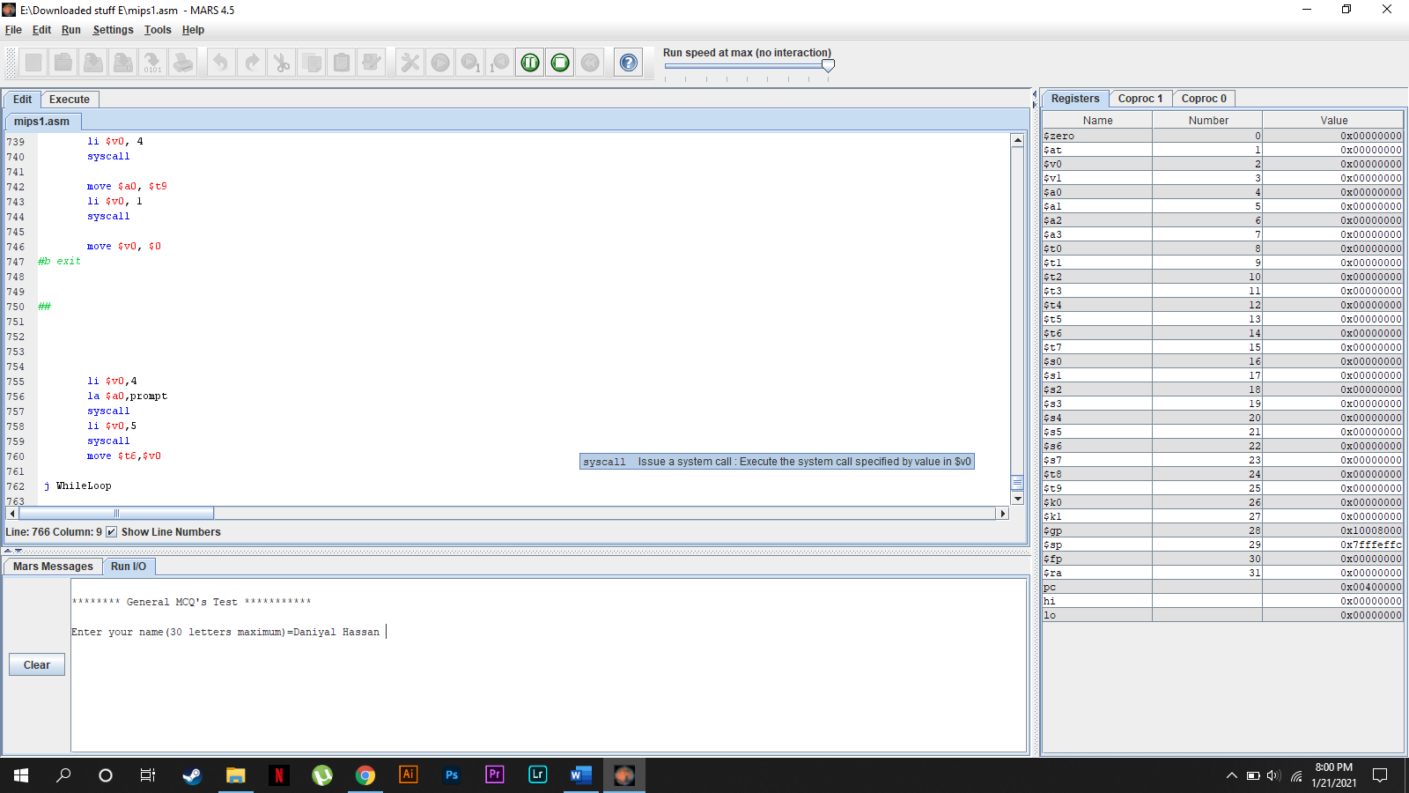

* **Main Menu:**

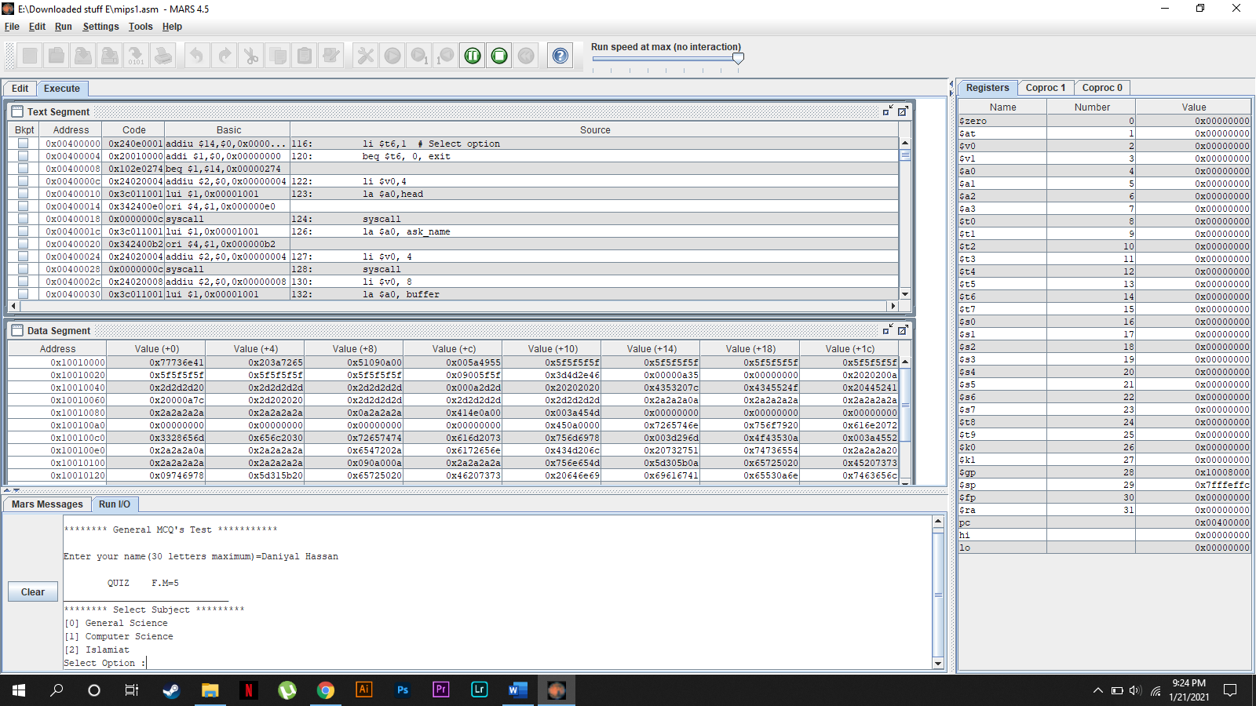

**Selecting Subject**

* **General Science:**

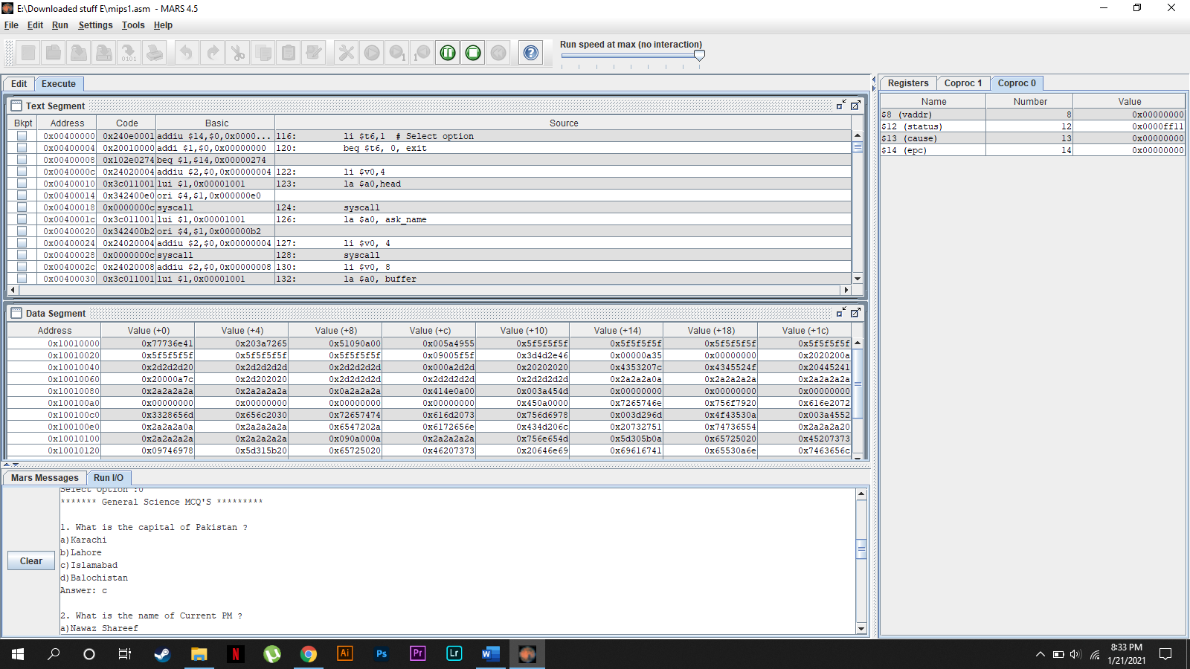

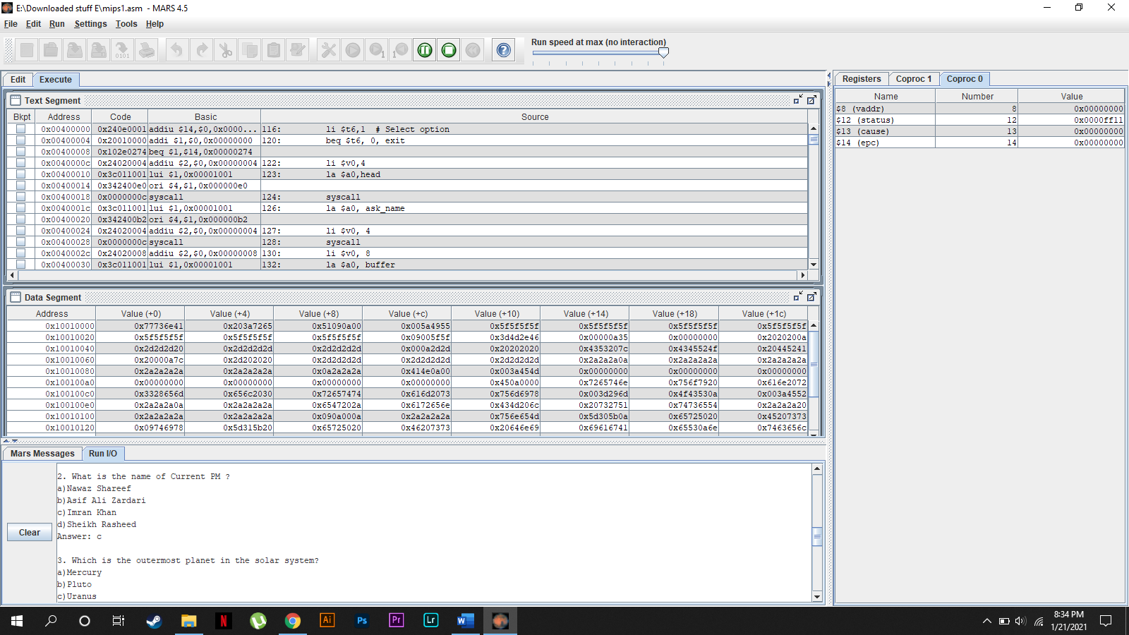

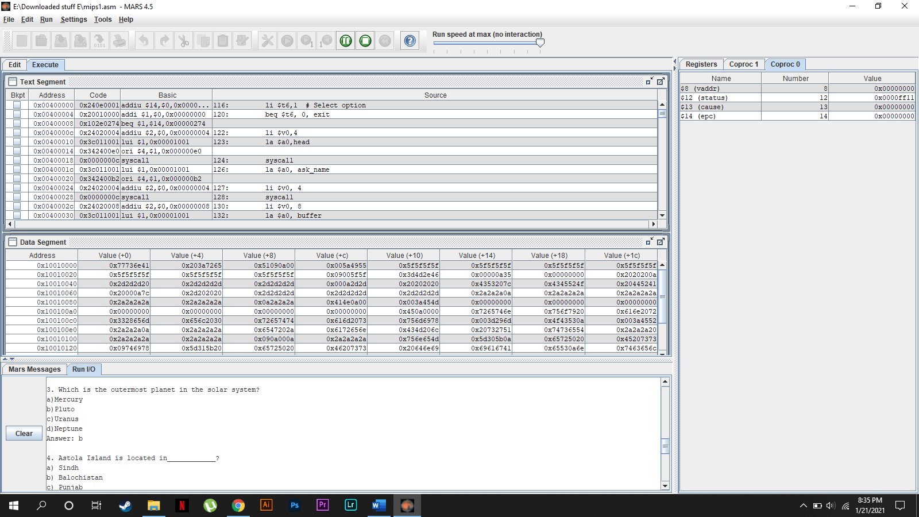

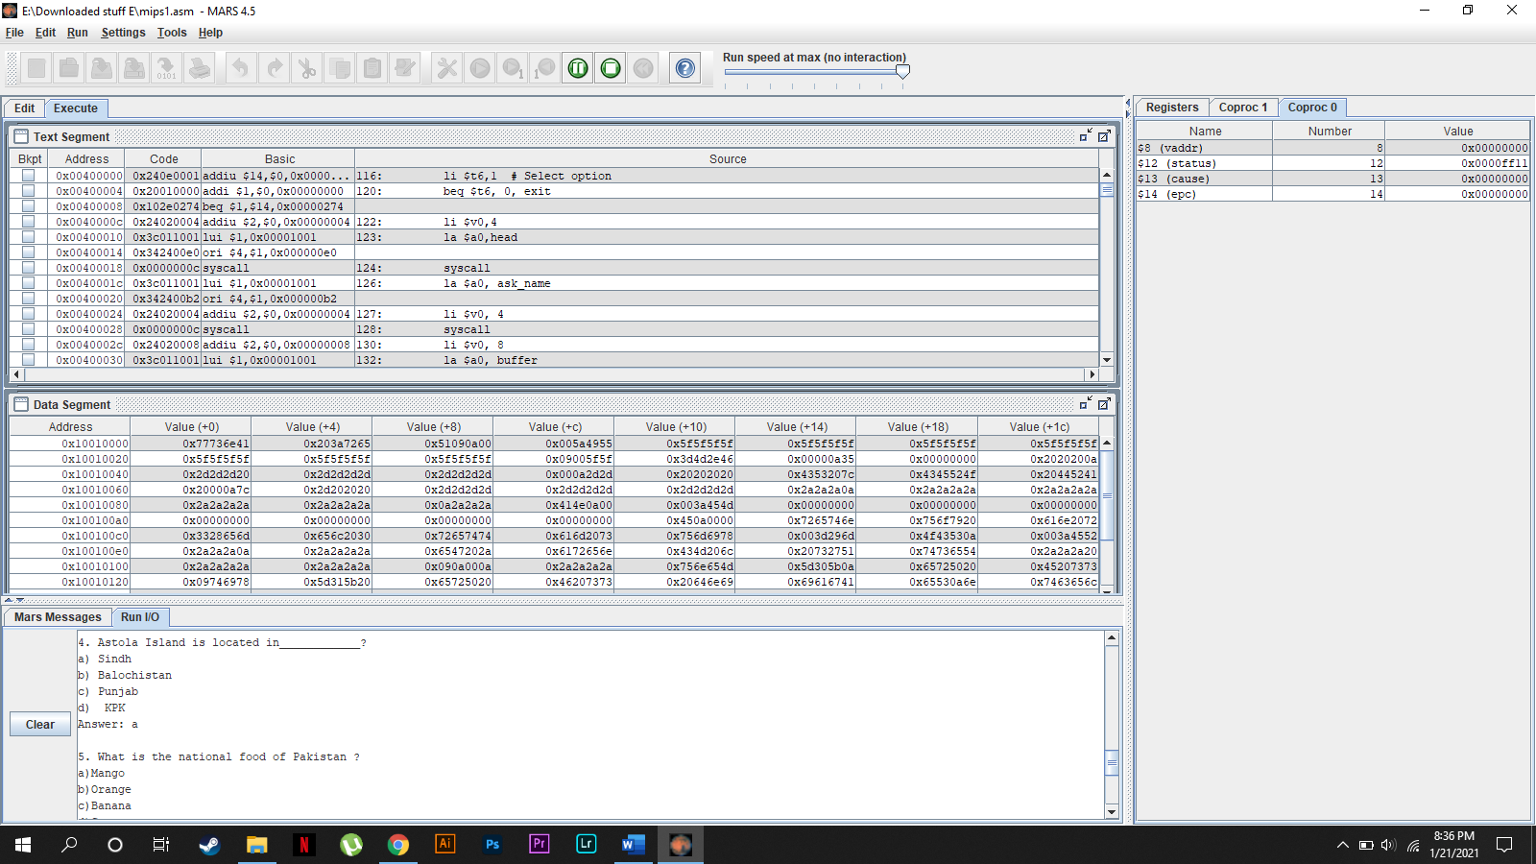

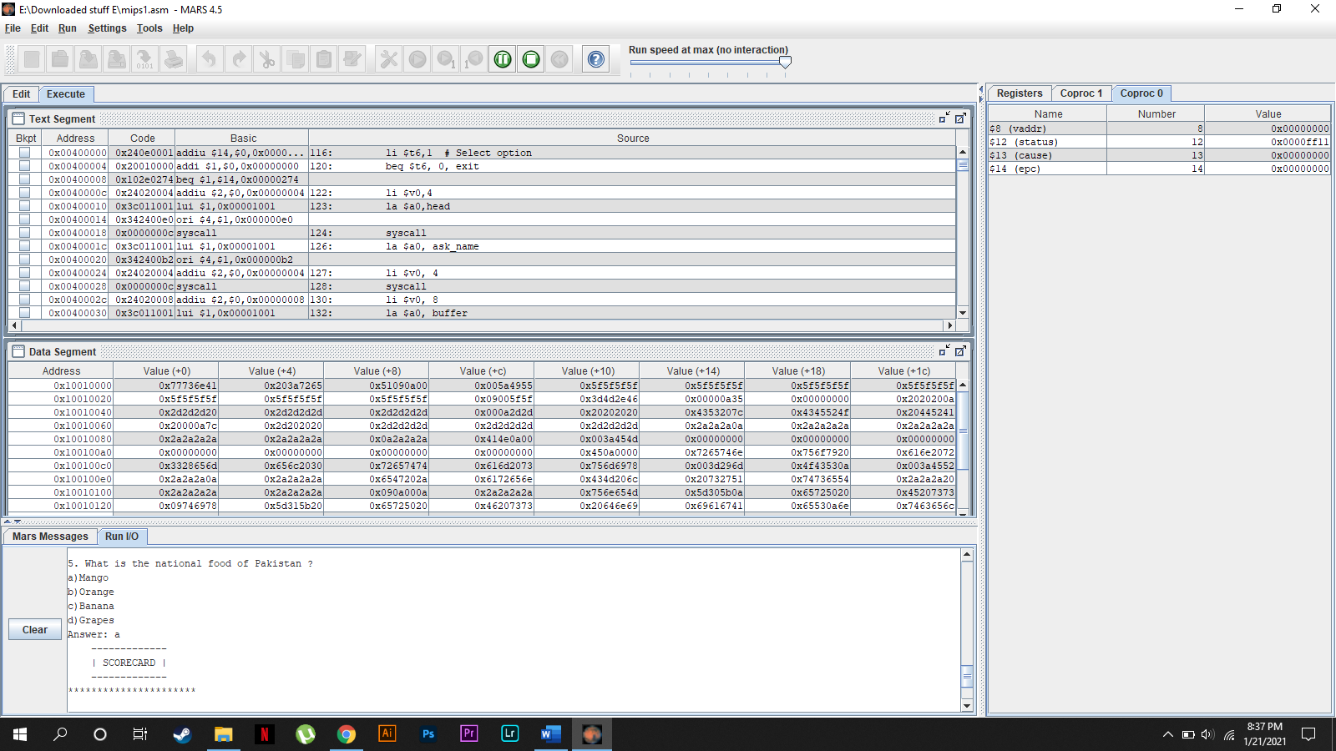

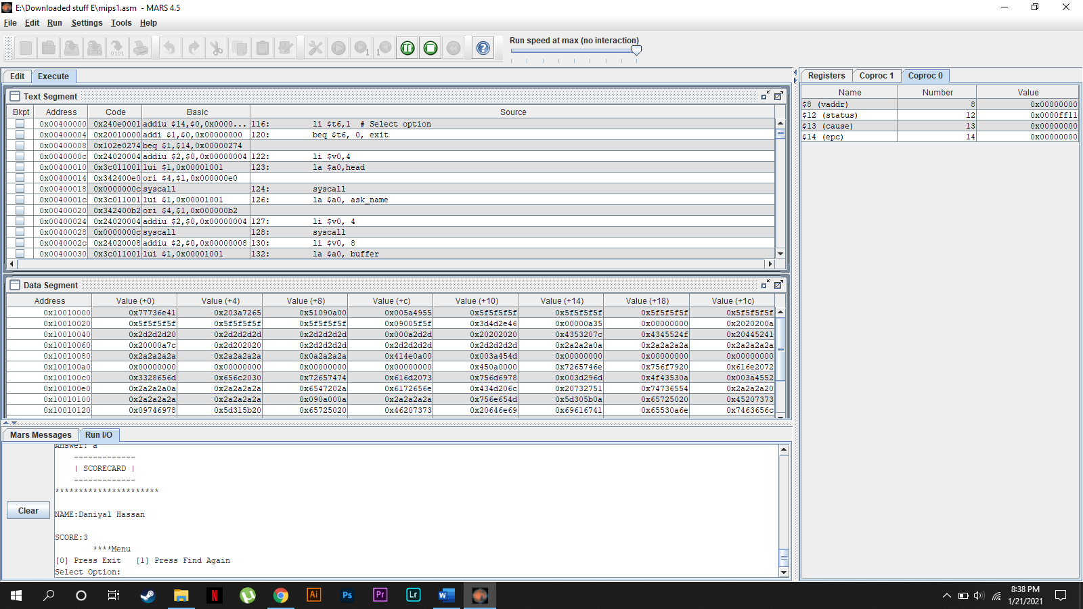

* **Computer Science:**

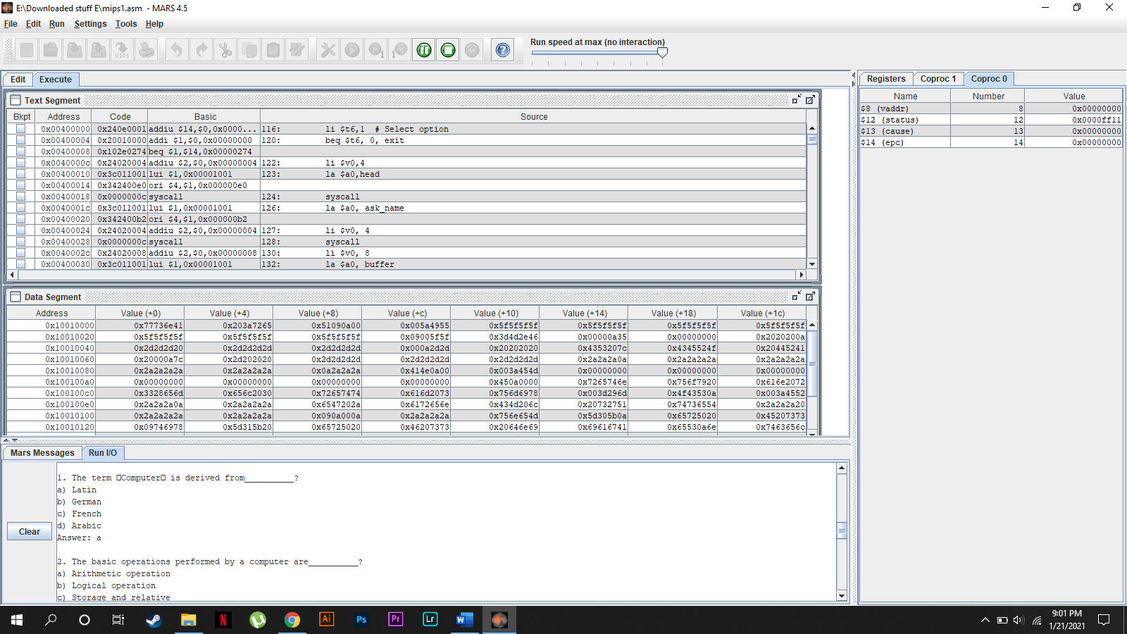

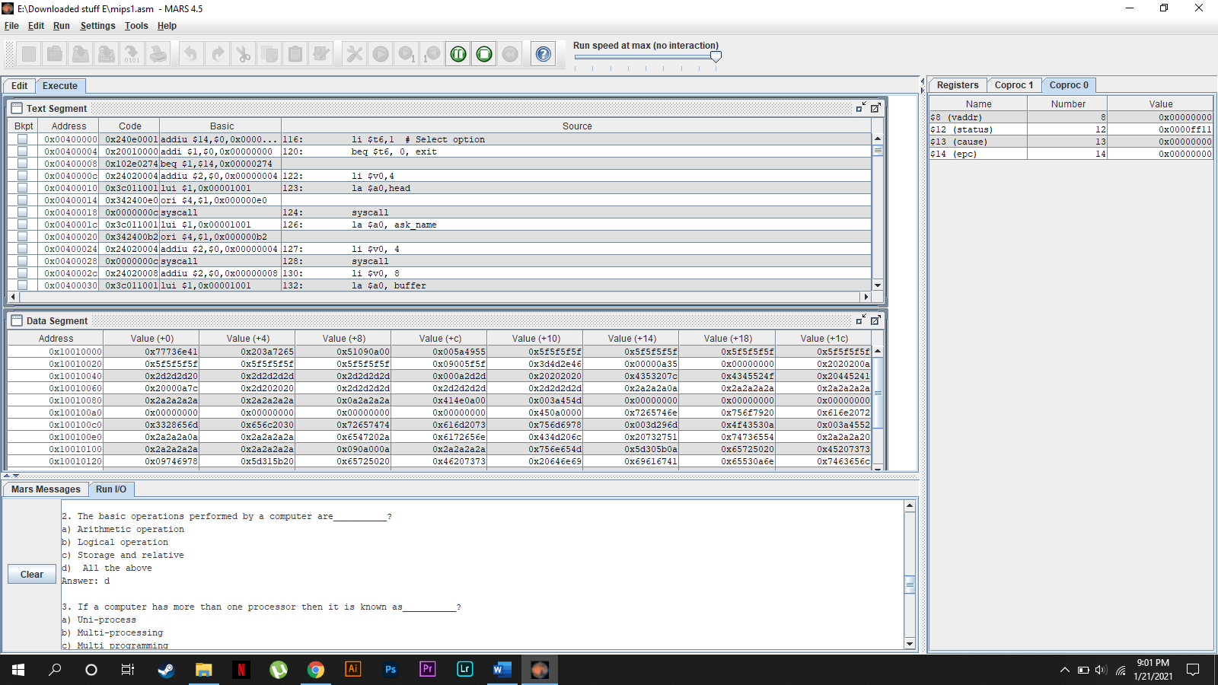

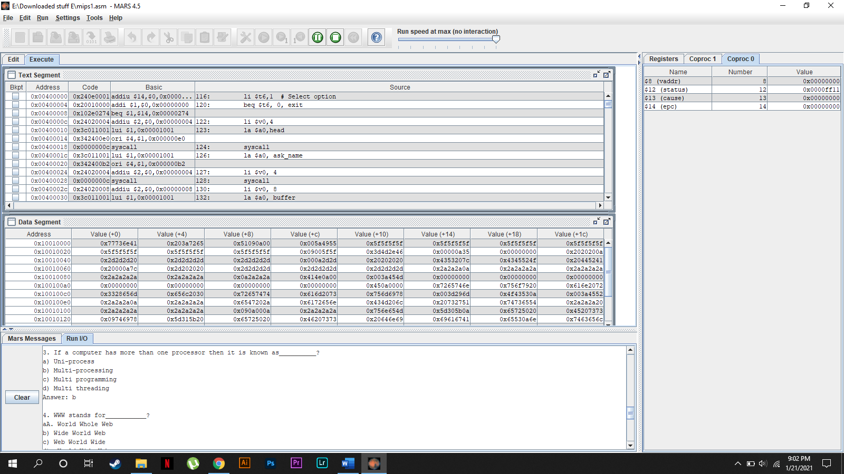

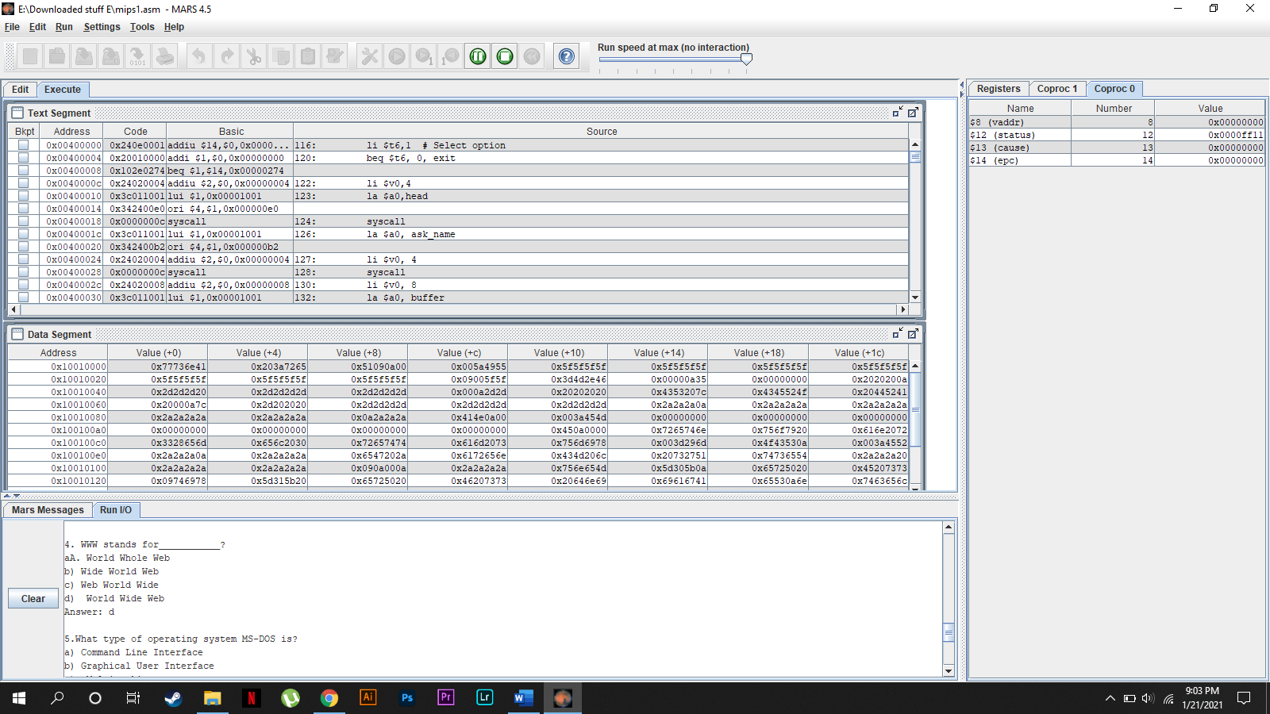

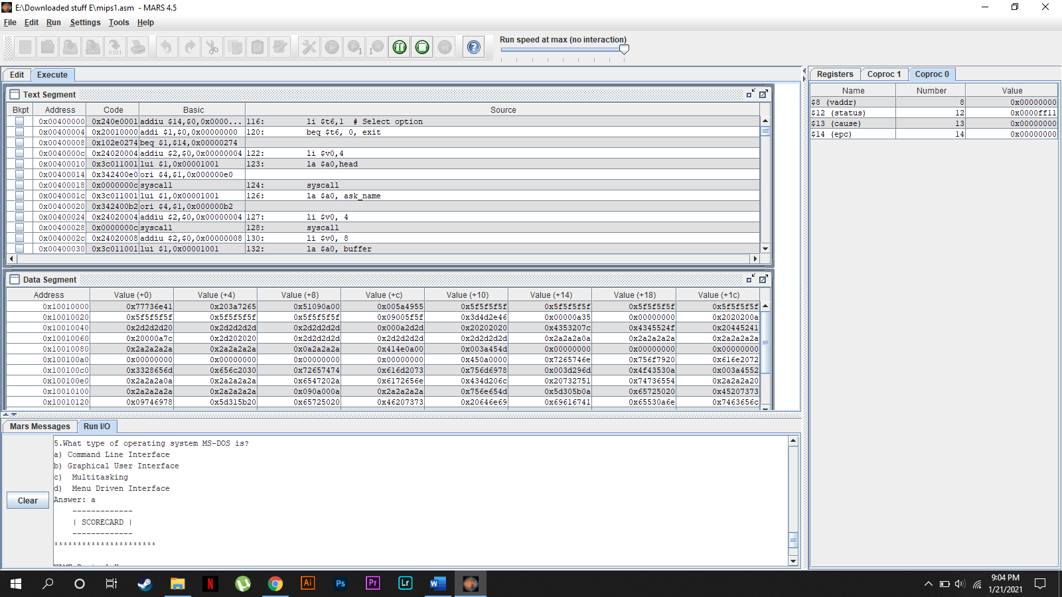

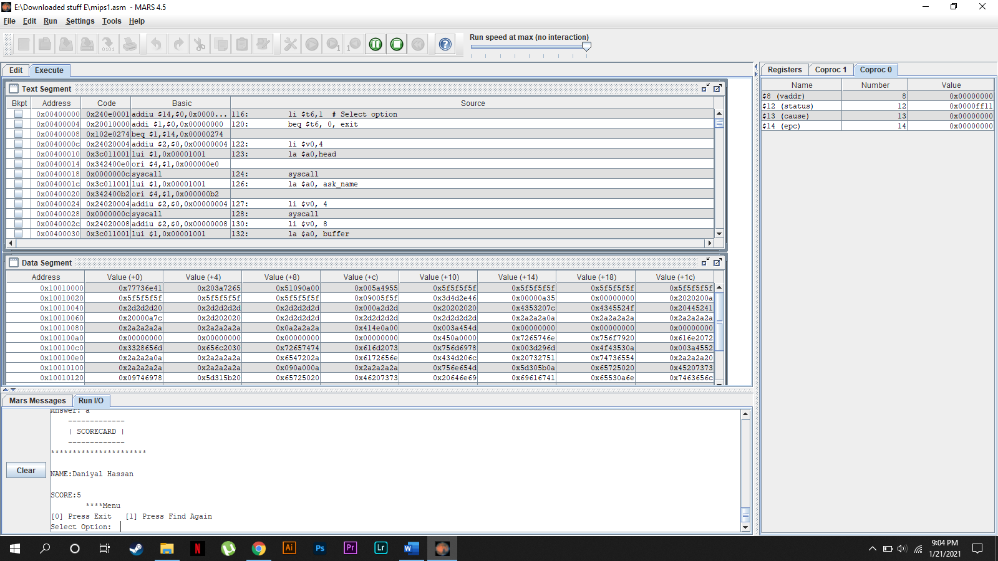

* **Islamiat:**

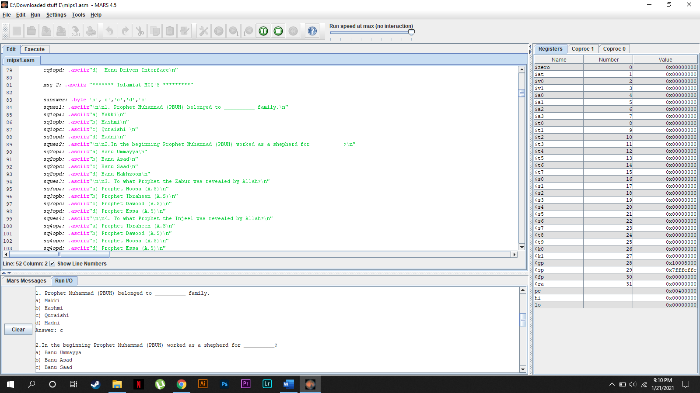

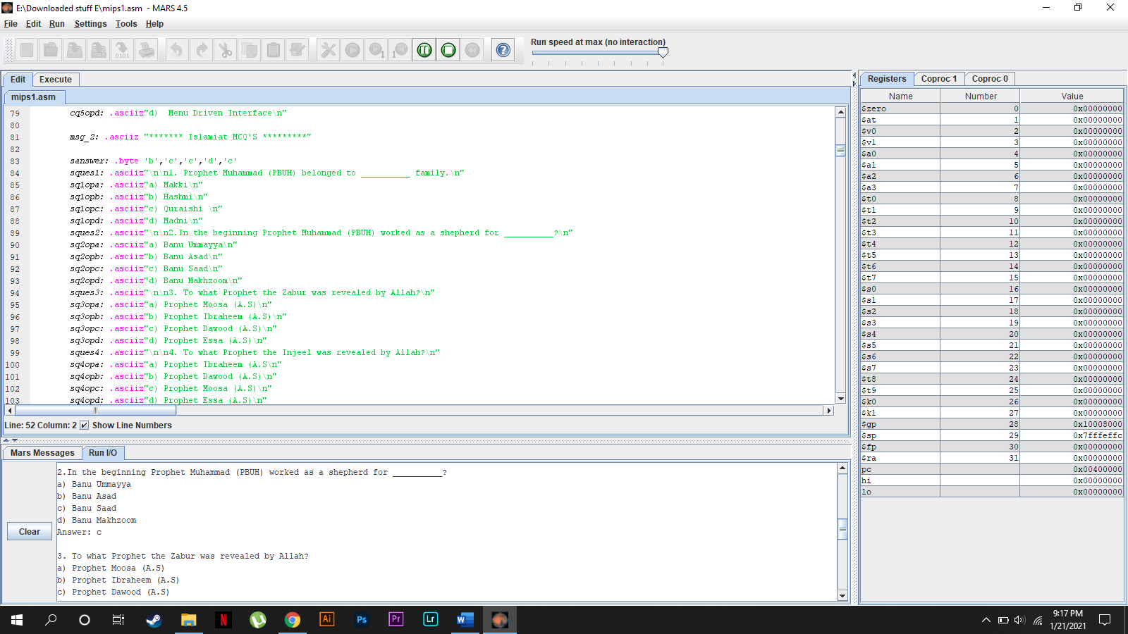

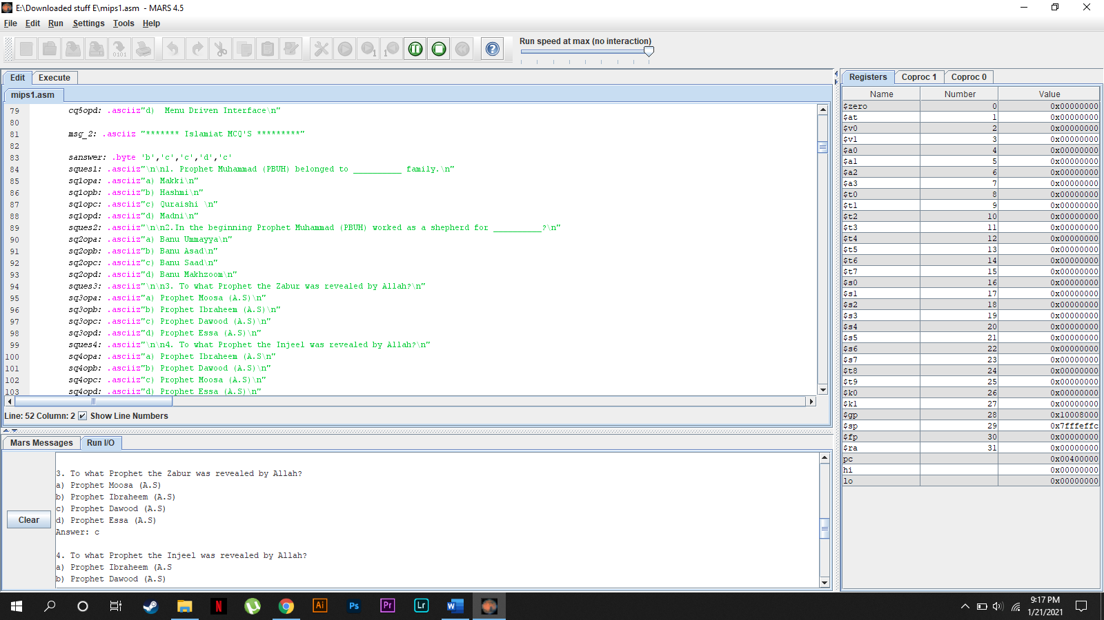

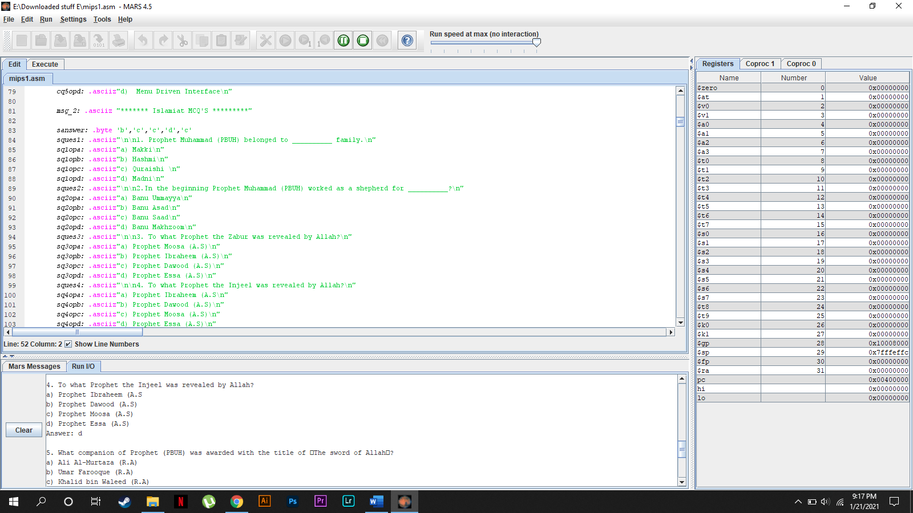

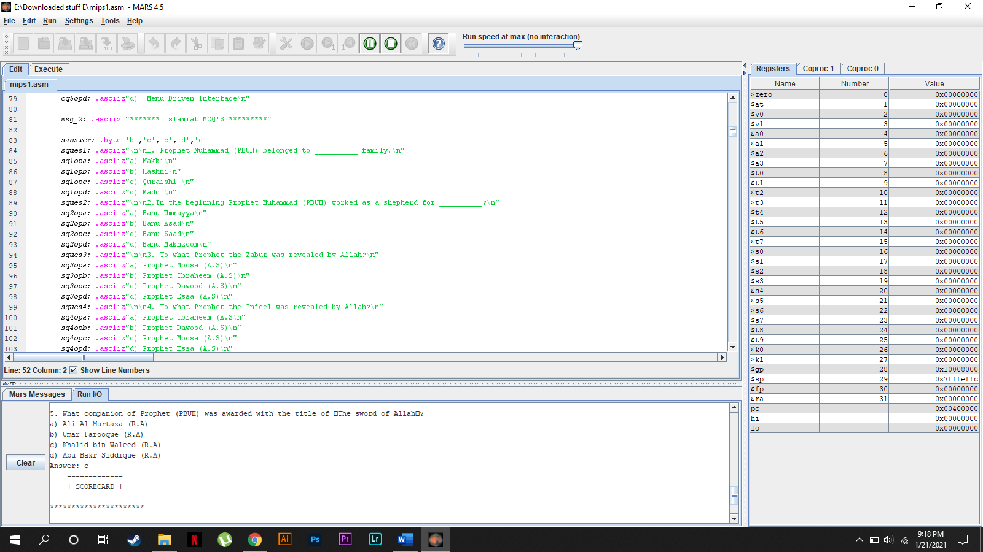

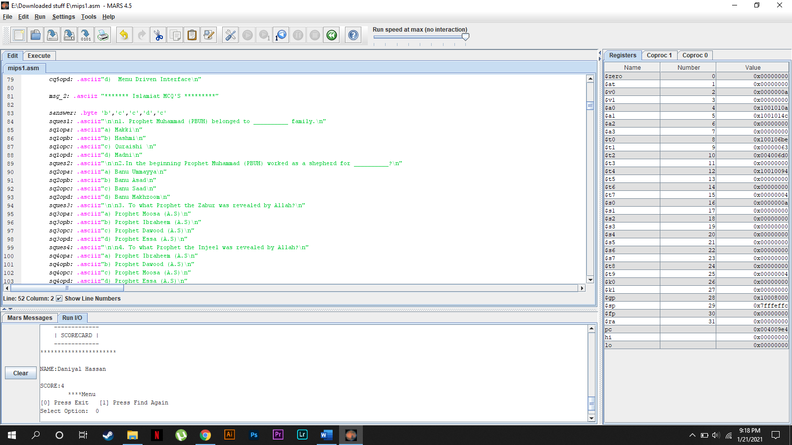

# **CONCLUSION:**

 As the education landscape is experiencing a steady change, it has become essential for Universities to use an innovative ****MCQs Based Test System**** to overcome present and future issues. Multiple Choice Questions (MCQs) are generally recognized as the most widely applicable and useful type of objective test items. They could be used to measure the most important educational outcomes - knowledge, understanding, judgment and problem solving.